Client: Anova Study: ABC
Figure 2.0
Subject counts by ARM
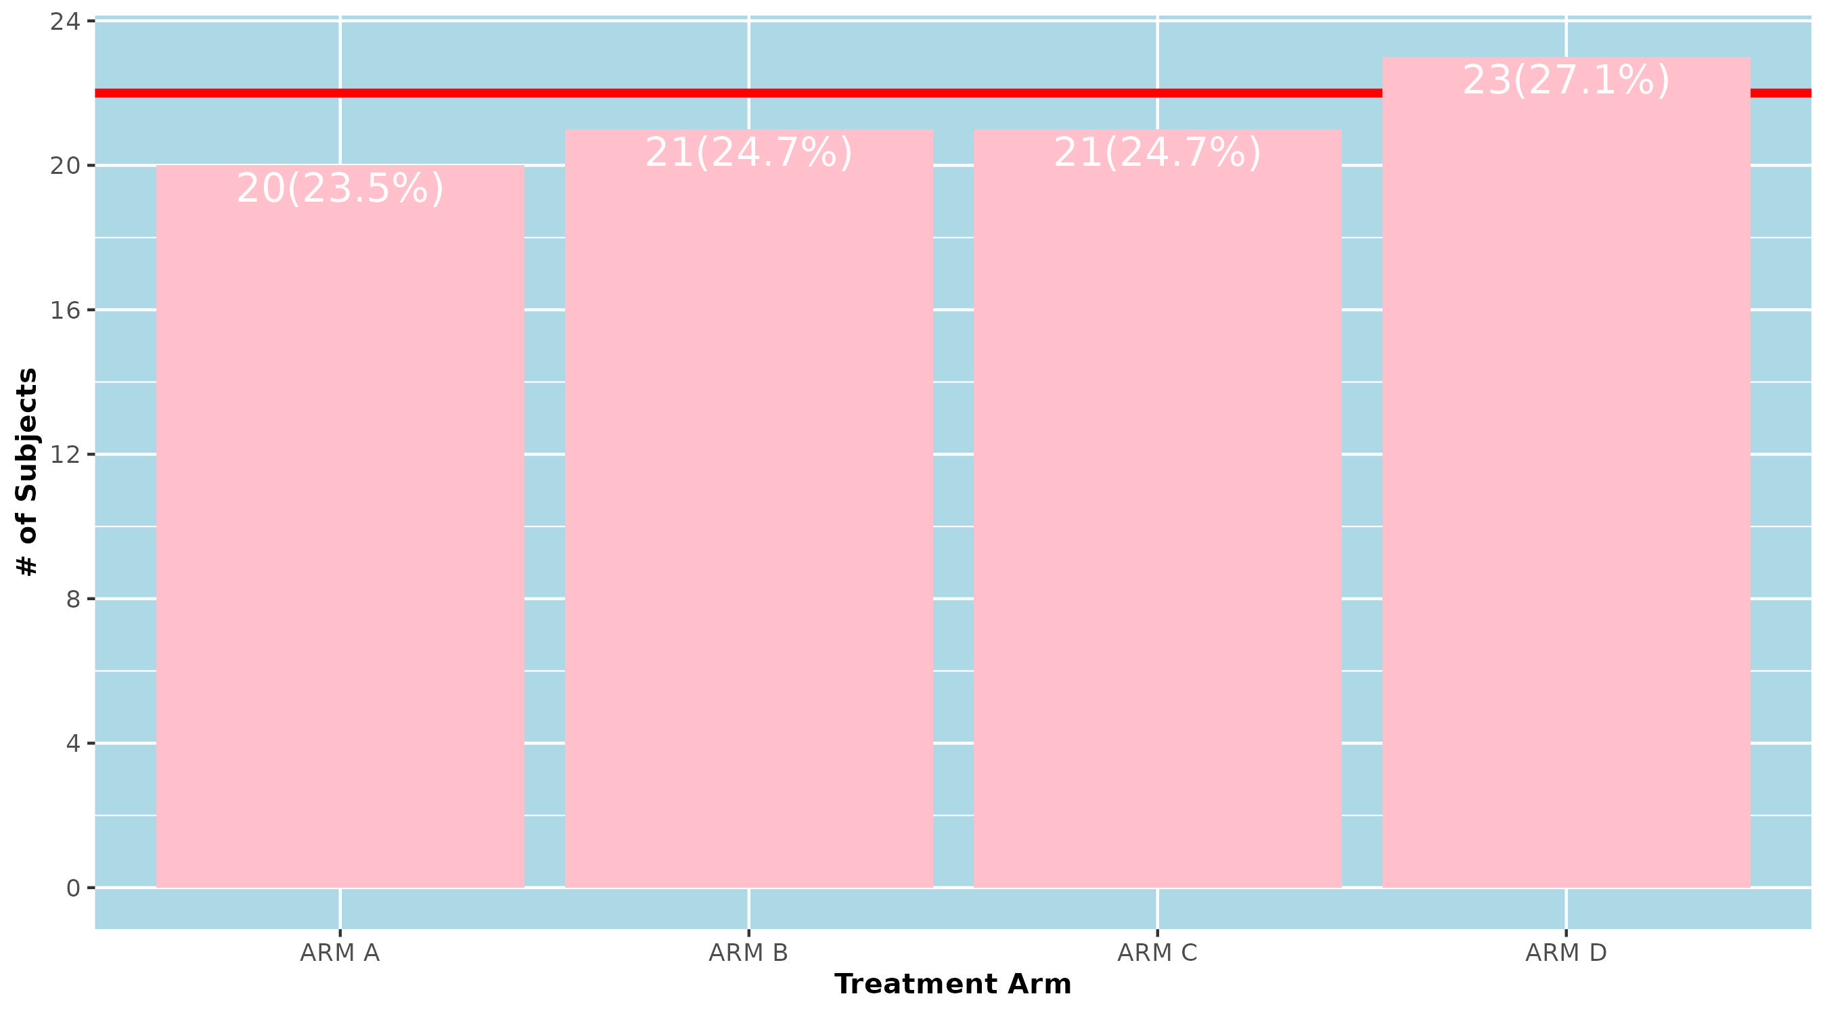
Note: Need at least 22 subjects to be a valid trial
Program: VS_Figures.R
2025-04-20 18:47:59.998628 Confidential Page 1 of 2
Client: Anova Study: ABC
Figure 3.0
Outliers of Pulse and Temperature (°C)
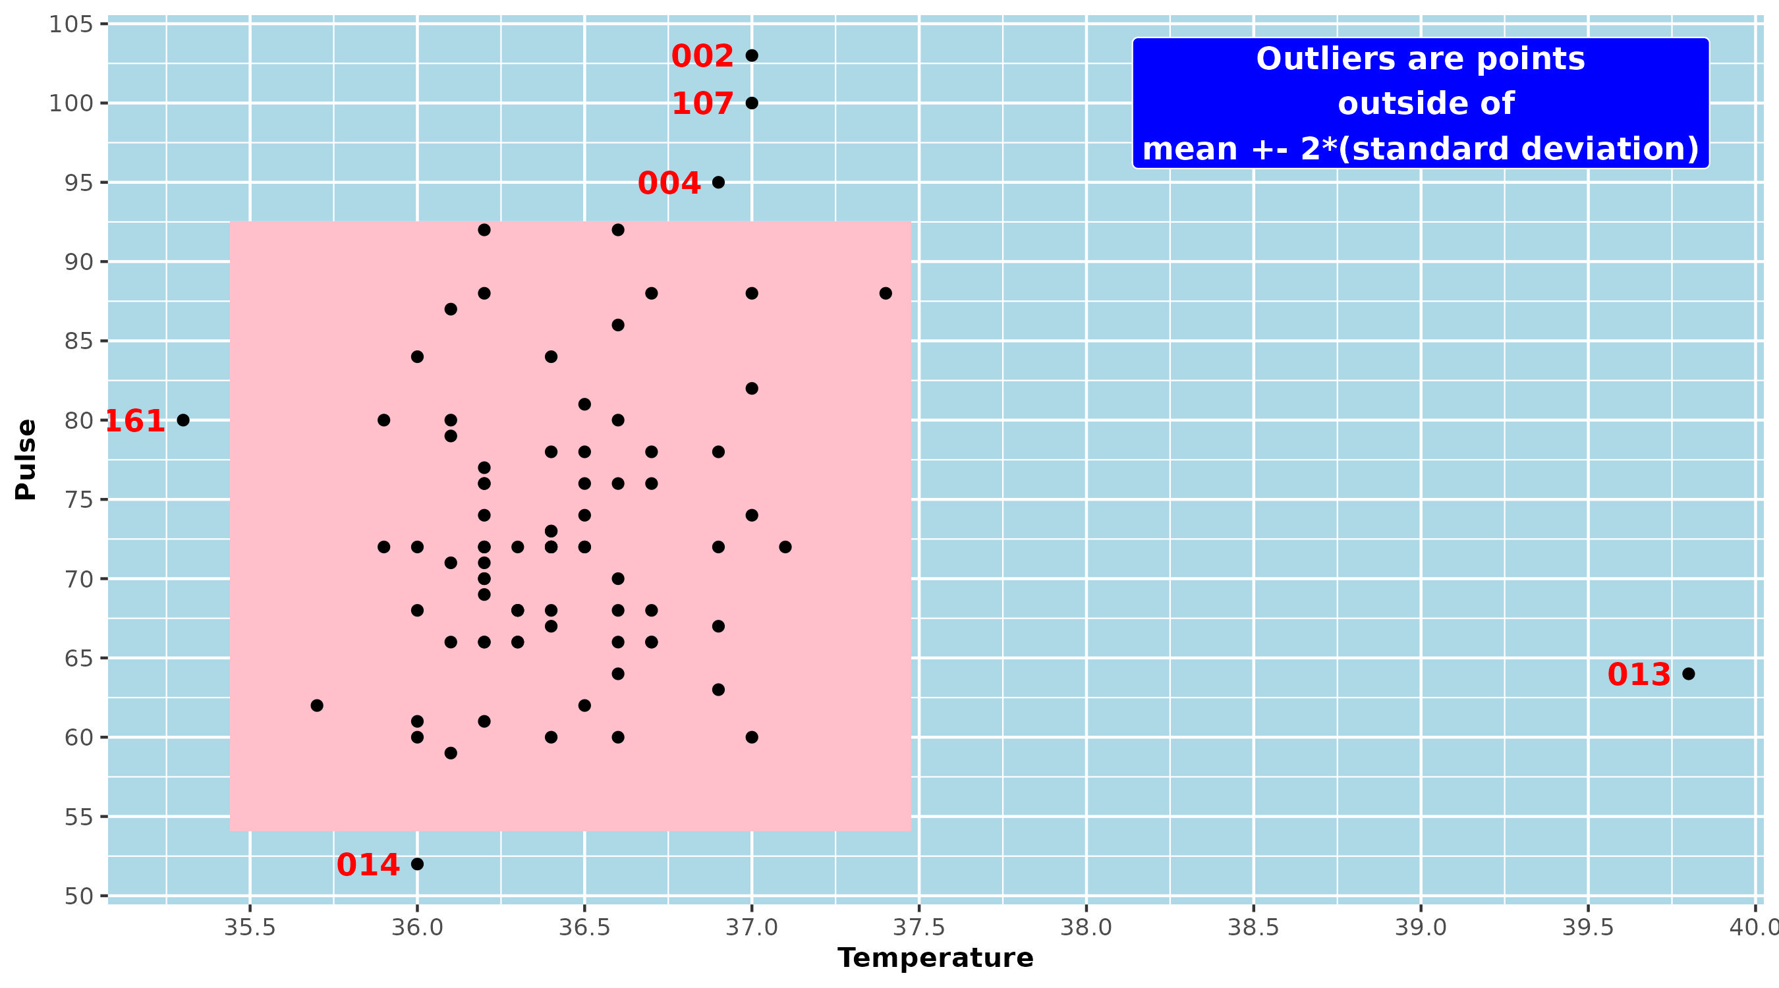
Note: Outliers are marked by a red subject # to the left of the data point
Program: VS_Figures.R
2025-04-20 18:47:59.998628 Confidential Page 2 of 2

